**LAB EXERCISE 1**

**NAME: NURUL ASYIKIN BINTI KHAIRUL ANUAR**

**MATRIC NUMBER: A23CS0162**

**SET 1**

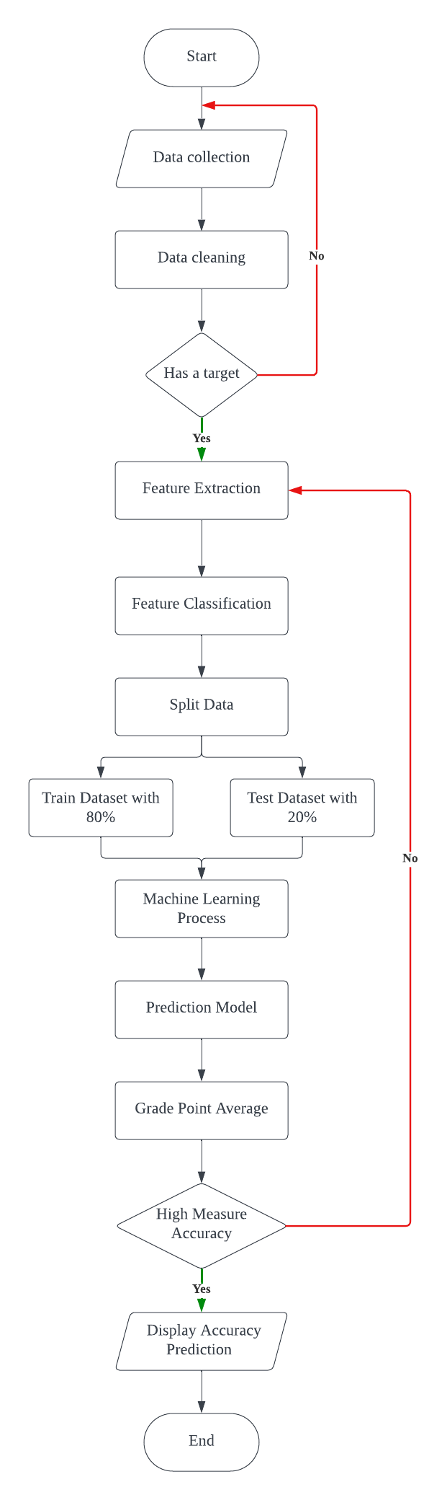

**SET 2**

1. Start

2. deposit = 0.10

3. Get the name, duration, package, customer_Type

4. If package == 1

4.1 rental = 150

5. Else If package == 2

5.1 rental = 250

6. End If

7. If customer_Type == Regular

7.1 discount = 0.10

8. Else If customer_Type == Normal

8.1 discount = 0

9. End If

10. price = rental * duration

11. deposit_Payment = deposit * price

12. total_Discount = discount * price

13. balance = price – deposit_Payment – total_Discount

14. Display name, deposit_Payment, total_Discount, balance

15. End

**SET 3**

1. Start
2. Get n
3. Let i = 0, product = 1
4. print “ Enter an integer number: “
5. while ( i < n )

5.1 Get integer_number

5.2 product = product * integer_number

5.3 i++

1. end while
2. if ( product % 4 == 0 && product % 5 == 0 && product % 7 == 0 )
   1. print product + “ is a multiples of 4, 5 and 7 “
3. else if ( product % 5 == 0 && product % 7 == 0 )
   1. print product + “ is multiples of 5 and 7”
4. else if ( product % 4 == 0 && product % 5 == 0 )
   1. print product + “ is a multiples of 4 and 5”
5. else if ( product % 4 == 0 && product % 7 == 0 )

10.1 print product + “ is a multiples of 4 and 7”

1. else if ( product % 4 == 0 )

11.1 print product + “ is a multiples of 4”

1. else if ( product % 5 == 0 )

12.1 print product + “ is a multiples of 5”

1. else if ( product % 7 == 0 )
   1. print product + “ is a multiples of 7”
2. end if
3. Stop

**SET 4**

1. Start
2. print “Enter the number of digit (n): ”
3. Get n
4. print “ Enter integer number: “
5. Let i = 0, product = 1
6. Do
   1. product = product * integer_number
   2. Get integer_number
   3. i = i + 1
7. while ( i < n )
8. end while
9. if (product % 2 == 0)
   1. print product + “ is an even number”
10. else
    1. print product + “ is an odd number”
11. end if
12. if (product % 3 == 0 && product % 5 == 0)
    1. print “ and multiples of 3 and 5”
13. else if (product % 3 == 0)
    1. print “ and multiples of 3”
14. else if (product % 5 == 0)
    1. print “ and multiples of 5”
15. end if
16. Stop

**FLOWCHART SET 4**

